**East West University**

**Department of Computer Science & Engineering**

**A/2, Jahurul Islam Avenue, Jahurul Islam City, Aftabnagar, Dhaka-1212**

______________________________________________________________________

**Lab Manual : 02**

**Course Code : CSE207**

**Topic : 2D Array**

**Course Title : Data Structures**

**Instructor : Md. Manowarul Islam, Adjunct Faculty, Department of CSE**

**Objective:**

The objective of this lab is to provide a fundamental idea about the sorting element of an integer array using C programming. At the end of the lab, students are able to know:

* How to take input into an array.
* Utilize 2D arrays for matrix manipulation and operations.

**Exercise 1**

We can add, subtract, multiply and divide 2 matrices. To do so, we are taking input from the user for row number, column number, first matrix elements and second matrix elements. Then we are performing any of the operations on the matrices entered by the user. Take the choice from user and show the results accordingly.

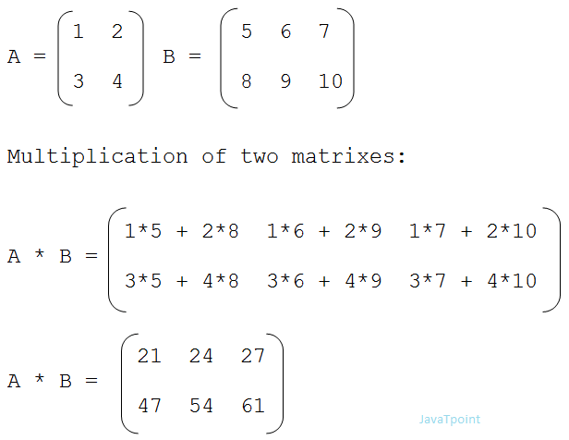



|  |  |
| --- | --- |
| **Sample Input** | **Sample Output** |
| **Enter your choice:**  1 for addition  2 for subtraction  3 for multiplication  Choose: 3  Enter the first matrix:  1 1 1  2 2 2  3 3 3  Enter the second matrix  1 1 1  2 2 2  3 3 3 | You choose 3  Multiplication:  6 6 6  12 12 12  18 18 18 |

**Exercise 2**

Write a C program to read elements in a matrix and find the sum of elements of each row and columns of matrix. C program to calculate sum of rows and columns of matrix.

|  |  |
| --- | --- |
| **Sample Input** | **Sample Output** |
| Enter the matrix:  1 2 3  4 5 6  7 8 9 | **Sum of rows:**  Row 1: 6  Row 2: 15  Row 3: 24  **Sum of columns:**  Column 1: 12  Column 2: 15  Column 3: 18 |

**Exercise 3**

Write a program in C to find the diagonal sum of a square matrix.

|  |  |
| --- | --- |
| **Sample Input** | **Sample Output** |
| **Enter the matrix:**  1 2 3  4 5 6  7 8 9 | **The diagonal Sum is** 15 |

**Exercise 4**

Write a program in C to find the transpose of a square matrix.

|  |  |
| --- | --- |
| **Sample Input** | **Sample Output** |
| **Enter the matrix:**  1 2 3  4 5 6  7 8 9 | 1 4 7  2 5 8  3 6 9 |

**Exercise 5**

Write a program in C that takes a 2D array as user input and finds the column with the maximum sum (i.e., identify the column whose sum of elements is the highest among all columns in the array).

|  |  |
| --- | --- |
| **Sample Input** | **Sample Output** |
| **Enter the matrix:**  1 2 3  4 5 6  7 8 9 | 3 No. column has the maximum sum  which is 18 |

**Exercise 6**

Write a program in C to find whether a matrix is identity matrix or not.

|  |  |
| --- | --- |
| **Sample Input** | **Sample Output** |
| **Enter the matrix:**  1 0 0  0 1 0  0 0 1 | This is an identity matrix. |

**Exercise 7**

You are given a 2D matrix of size n×nn \times nn×n. Write a program to rotate the matrix 90 degrees **clockwise** in-place, meaning the transformation should not use any additional 2D matrix for storing the result.

**Input:**

1. An integer nnn: the size of the square matrix.
2. A 2D matrix matmatmat of size n×n containing integers.

**Output:**

The modified matrix after rotating it 90 degrees clockwise.

|  |  |
| --- | --- |
| **Sample Input** | **Sample Output** |
| **n=3**  **Enter the matrix:**  1 2 3  4 5 6  7 8 9 | 7 4 1  8 5 2  9 6 3 |

**Exercise 8**

A **saddle point** in a matrix is an element that is the **minimum in its row** but also the **maximum in its column**. Given a 2D matrix of size m×n, your task is to find and print all **saddle points** in the matrix.

**Input:**

1. First line: Two integers m(number of rows) and n(number of columns).
2. Next mmm lines: Each line contains nnn integers representing the matrix.

**Output:**

* If a saddle point is found, print the value and its position (row, column).
* If no saddle point exists, print "No saddle point found."

|  |  |
| --- | --- |
| **Sample Input** | **Sample Output** |
| **m=3, n=3**  **Enter the matrix:**  4 8 7  2 5 6  3 9 1 | **Saddle Point:** 5 at position (2, 2) |